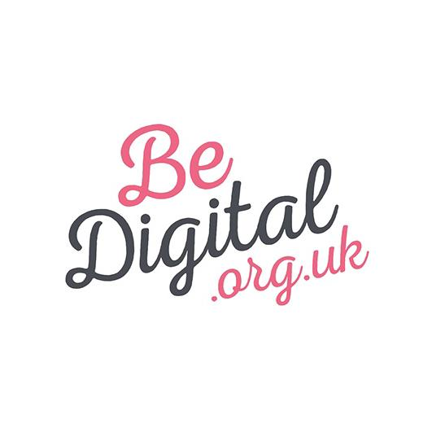

Be Digital Springboard Programme Application Form

Please complete your Springboard Programme application form in full and submit it by the closing time and date of 5pm on Wednesday 30th September.
Once submitted, if you reflect back and think there is more you would like to add, or anything you would like to change, please do feel free to re-submit your application, so long as this is done before the deadline.
After the closing date of 5pm on Wednesday 30th September, the Springboard Programme Panel will review all applications. The 20 winning applications will be announced on Monday 19th October. The Springboard Programme will start soon after, during week commencing 26th October 2015.
We very much look forward to receiving your application - best of luck!
If you have any queries at all about the application process please email Fay and Anita at the Be Digital team by email to hello@bedigital.org.uk.
* Required - please answer all of the questions listed below.

-----------------------------------------------------------------------------

Part 1 – About Your Business

What makes your business (idea) unique and/or how does it stand out from the crowd/competition? *

Who will buy from you and why? What problem(s) does your service or product solve? *

Which feature or facet of your business are you the most proud of? *

What are your goals and aspirations for your business over the next 3 years? *

Part 2 – About You
Why did you start your business or how did you come up with your business idea? *

What are the biggest problems you have had in your business and how did you deal with these? What was the outcome? *

What are your key strengths and key skills that would benefit in the other participants? In which areas could you do with their support? *

Part 3 – About Being Digital
How are you currently using broadband and digital solutions to support your business? *

What aspects of being a digital business do you find the most challenging or confusing? *

In what way do you think that this programme of support will help you to significantly grow and develop your business, compared to you simply doing this on your own? *

Part 4 - Your Details
Your Full Name *:

The Name of Your Business *:
Please provide your best contact number *:
Your Business Address * (Northumberland's Be Digital Springboard Programme is funded for delivery to women-led businesses based in Northumberland - please provide the full address including postcode of the registered or trading address for your business below.)

A link to your website * (If you don't have a website address yet, please provide a link to the main social media account you use for your business, such as your facebook or twitter page.)

Your email address *:

